Goals:

* Group by “clear_change” and service type to look for a trend

*many null values for clear change. Switched to likely_recommend rating

* Join org_data and survey_data so that I can find average rating per team

*Team 8 is outlier

* Compare ratings by survey type
* Compare virtual and on-site service outcomes
* Breakdown of valuable use of time by submitter role
* Ratings over time
* Degree of confidence in Plan brought by Instruction Partners

Database image:

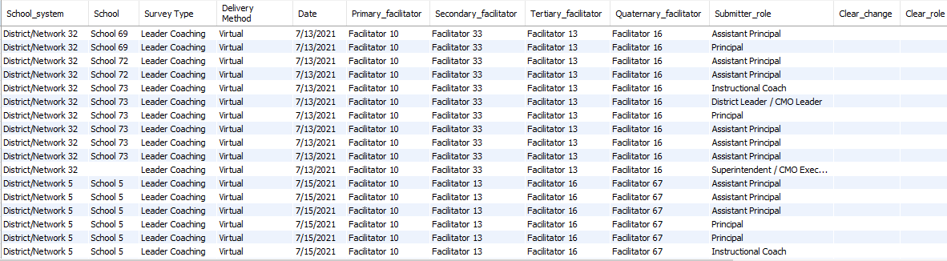

Output summary:

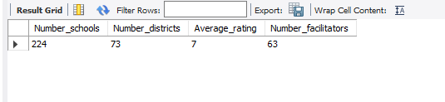

Number of schools: 224

Number of districts: 73

Average rating